|  |  |  |  |
| --- | --- | --- | --- |
| **SVKM's-IOT, Dhule**Shri Vile Parle Kelavani Mandal's  **INSTITUTE OF TECHNOLOGY**  **DHULE (M.S.)**  **DEPARMENT OF COMPUTER ENGINEERING** | | | |
| **Subject :** Data Structures Lab | | | Remark |
| **Name :**  Ansari Asharul Ameen Naeem Ahmad | | **Roll No. :** 63 |
| **Class :** SY. Comp. Engg. | **Batch :** S4 | **Division:** A |
| **Expt. No. :**10 | **Date :** | | Signature |
| **Title :** Write a java program on interfaces and Static and Dynamic binding | | |
|  | | |
|  | | |

**Code1 :**

interface A {

void methodA();

}

interface B {

void methodB();

}

class multi implements A, B {

public void methodA() {

System.out.println("This is methodA from interface A");

}

public void methodB() {

System.out.println("This is methodB from interface B");

}

public static void main(String[] args) {

multi obj = new multi();

obj.methodA();

obj.methodB();

}

}

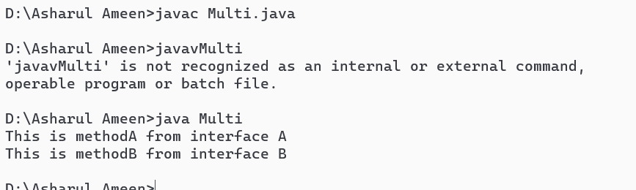

interface MyInterface {

void displayMessage();

}

class MyClass implements MyInterface {

public void displayMessage() {

System.out.println("Hello, this is an interface implementation.");

}

}

public class Multiple {

public static void main(String[] args) {

MyClass obj = new MyClass();

obj.displayMessage();

}

}

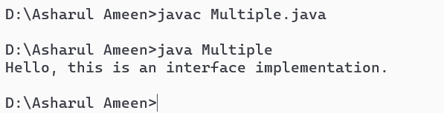

class Animal {

void sound() {

System.out.println("Animal makes a sound");

}

}

class Dog extends Animal {

void sound() {

System.out.println("Dog barks");

}

}

public class Main{

public static void main(String[] args) {

Animal animal = new Animal();

animal.sound();

Animal dog = new Dog();

dog.sound();

}

}

